

JOB DESCRIPTION

1. Job Details

Job Title: Allied Healthcare Professional (AHP) Placement Project Manager
Job grade: Proposed Band 7 (awaiting AFC banding)
Hours: Full Time or part time
Reports to: Nottingham and Nottinghamshire ICS (NICS) AHP cabinet
Directorate: Corporate directorate SFHT on behalf of NICS
Location: ICS wide based at King's Mill Hospital

2. Job Purpose

This role will primarily examine opportunities across the NICS to expand the number and quality of placements for Black, Asian and Minority Ethnic (BAME) student Allied Healthcare Professional (AHPs). Under the guidance and mentorship of Workstream Leads for the Clinical placement expansion programme (CPEP), and alongside clinical and operation staff to plan and deliver schemes.

Reports to: CPEP workstream lead, NICS AHP Cabinet via Associate Chief AHP SFHT:

The overriding purpose is to support the provision of the highest quality and diverse AHP undergraduate workforce through personal actions and continuous improvement.

3. Role of the Department

4. Organisational Chart

NICS AHP Cabinet
AHP SFHFT Associate Chief

CPEP workstream leads

AHP Placement Project Manager

5. Key Result Areas

- To collate and analyse data to understand the population diversity across the ICS

- To understand how the demographics translate to applicants to HEI AHP undergraduate careers

- To gain insight to BAME AHP Student experience across the ICS

- To promote AHP careers at an appropriate level to encourage applicants from a diverse background

- To outline recommendations in relation conversion rate from undergraduate to registrant AHP posts

- To feedback to the Nottingham and Nottinghamshire ICS AHP Cabinet against agreed project aims

This role works under the guidance and mentorship of CPEP workstream leads, and alongside clinical and operation staff to plan and deliver improvement schemes. The post holder is responsible for managing the process to develop improvement ideas through inception to presentation and where possible delivery.

The post holder is specifically required:-

- To support the NICS AHP Cabinet to formulate robust, logical plans that lead to clear outcomes and benefits, and to identify the key milestones and metrics.

- To work with and develop relationships with key stakeholders to oversee the robust and effective delivery of projects.

- To manage risks, assumptions, issues and dependencies at planning and throughout the project lifecycle.

- To work with NICS AHP Cabinet to ensure that there are robust plans for placement that reflect agreed and improved ways of working across all aspects of clinical care which underpin the delivery of high quality and safe patient care.

- To work in collaboration with key stakeholders, to develop approaches for monitoring the implementation of service improvements across the whole improvement portfolio.

- To effectively communicate to promote the benefits of the improvement approach.

- To provide regular updates, progress reports and recovery reports.

General Issues

The post holder will ensure the Trust policies with regards to the Health and Safety at Work Act are implemented at all times

Due to the nature of the work a flexible and mutually agreed work pattern will be required.

Infection Control Statement
All employees have an individual responsibility to have knowledge of and employ the basic principles of infection control practice and to ensure adherence to the requirements in the Infection Control Manual.

Any Other Duties Statement
To undertake any other duties which may be reasonably regarded as within the nature of the duties, responsibilities and grade of the post as defined, subject to the proviso that appropriate training is given and that wherever possible significant changes of a permanent nature shall be mutually agreed and incorporated into the job description in specific terms and the post re-evaluated if the change is likely to result in a job evaluation score change.

6. Physical and Mental Skills

Communication Skills
There will be a requirement to provide and receive highly complex information verbally, in writing and electronically. There will be a need to persuade and motivate staff to develop and adopt new practices, which at times may prove highly contentious, requiring sensitive handing.

There will be a requirement to facilitate and present information to both small and large groups through complex processes.

Analytical and Judgemental Skills
The post holder will be expected to provide regular analysis and make judgements on complex facts, interpret national and best practice guidance, identify key milestones and risks and provide resolution to problems and failures, from a range of options, in order to deliver the objectives to the required standards.

Planning and Organisational Skills

Responsible for planning; and organising a broad range of complex service improvement programmes and projects; manage a wide variety of project elements and on-going processes. There will be a requirement to make adjustments to projects and strategies as required to meet quality standards and targets on an on-going basis.

Physical Skills

The post holder will be required to be computer literate with advanced keyboard skills, with the inputting of accurate data being essential.

An ability to collate and present information to inform management debates via the regular development of reports and databases using computer packages, i.e. Excel, PowerPoint, Access, Word and Project.

The post holder will regularly be required to drive to different locations across the local health community for meetings.

7. Responsibilities of the Post Holder

The prime responsibilities of this role are to be actively scope and understand the current baseline position with respect to workforce diversity and understand constraints and potential improvements.

The post holder will be integrated into a team where new ideas and concepts will be planned and tested with the expectation that proven improvements are implemented across all current services. Advice and professional input will be required throughout the whole process of pathway redesign. The expertise of existing staff from diverse backgrounds and with a range of beliefs is invaluable for this redesign process.

Key Relationships

The post holder will have key relationships with the AHP ICS Cabinet, Staff Networks, Health Education Institutes, members of the public and external Groups to the Trust. They will be advocates for the AHP Professions and Nottinghamshire ICS.

Responsibility for Policy / Service Development

The post holder will be expected to follow the SFHT policies and procedures and follow national guidance aligning to the principles and objectives of the Nottingham and Nottinghamshire ICS.

Responsibility for Financial and Physical Resources

To develop and maintain a database for the AHP BAME potential, undergraduate and post graduate workforce, including a flag system to ensure progress reporting is carried out in a timely fashion.

The post holder is responsible for ensuring appropriate and safe use and storage of equipment and resources in a variety of different work settings.

Responsibility for Information Resources

To create and develop local information resources in relation to BAME students and career choices, demonstrating an understanding of Equality, Diversity and Inclusion and to promote and embed the agenda within the Nottingham and Nottinghamshire ICS. This will include production of reports as required

Research and Development

Carry out baseline audits of information, by area, in order to assess and measure the effectiveness of service improvement initiatives.

8. Freedom to Act

Objectives and results will be defined for the post holder; however there will be an expectation that the post holder will have freedom to determine how best these are achieved. Guidance will be provided by the CPEP Workstream Lead, NICS AHP Cabinet and the post holder will have discretion to work within defined parameters.

9. Physical, Mental and Emotional Effort Required

There will be a combination of sitting, standing and walking activities. There will be a requirement to carry equipment to and from meetings.

There will be a frequent requirement for prolonged concentration when working with staff to identify and implementing complex process changes, analysing information and producing reports.

Emotional effort will be required when dealing with all levels of staff and internal stakeholders. The planning and implementation of initiatives will at times call for determination in the face of criticism and potential hostility from what may be senior staff members - the post holder will be required to cope with this pressure (provided it remains within the boundaries of the Trust's HR policies) and still deliver results.

Generally the work pattern should be of a predictable nature.

10. Outline of Working Conditions

The post holder will be required to observe practice and meet with colleagues in a range of environments including healthcare and educational, and may on occasions be faced with distressing situations.

The post holder may occasionally be exposed to verbal aggression from members of staff when dealing with contentious issues.

There will be a requirement to use VDU equipment on a regular basis, including the management of own electronic diary, emails and the production of papers and reports.

KSF OUTLINE

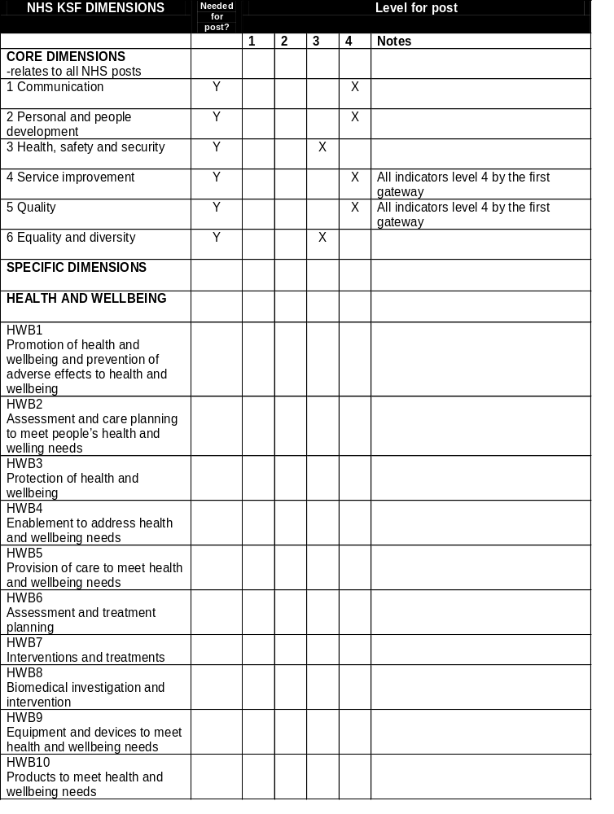

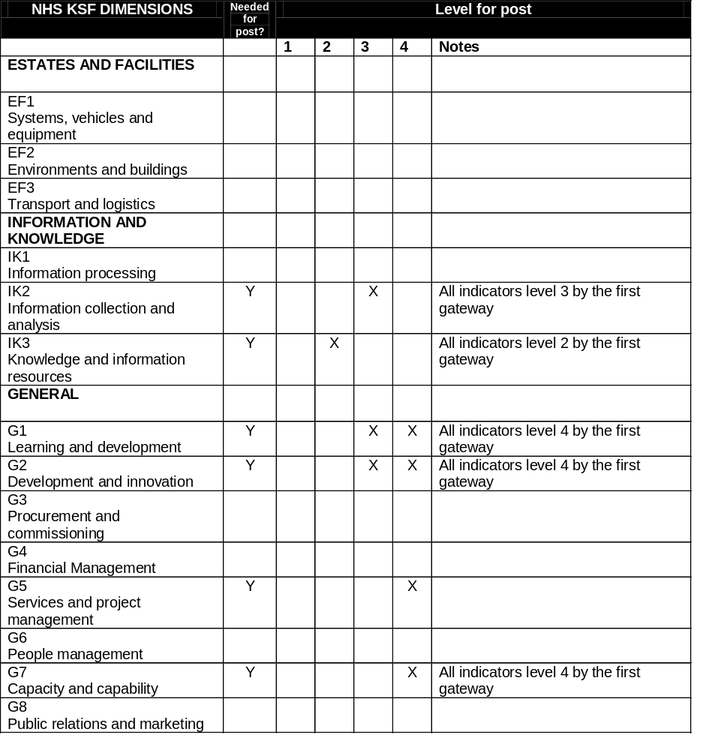

Job Description Agreement

Job Holder’s Signature………………………………….. Date……………………………………

Line Manager’s Signature………………………………….. Date……………………………………

Sherwood Forest Hospitals NHS Foundation Trust

Person Specification

AHP Placement Project Manager
Attribute | Essential | Desirable | How Identified
Knowledge and Skills  Requirements | Specialist subject matter knowledge of project management theory, tools and techniques.  Understanding of how to define and measure quality improvement.  Ability to identify, understand and manage change opportunities.  Prioritisation and time management skills.  IT literate and knowledgeable in the use of Microsoft applications.  Advanced report writing and presentation skills  Understand undergraduate AHP provision and Higher education institutions throughout the Integrated Care System (ICS).  Excellent communication and interpersonal skills, including negotiation, and facilitation and able to convey highly complex information and ideas clearly and succinctly.  The ability to analyse complex data. Identifying the main issues in complex problems, clarifying understanding and representing stakeholders..  Highly skilled in formulating solutions to problems and managing those solutions through to project presentation.  Acting as a role model in supporting and energising teams and individuals to build confidence in their ability to deliver outcomes.  Knowledge of staff and change management at a senior clinical level.  Ability to formulate clear, robust and deliverable plans taking into account information from multiple sources.  Advanced keyboard skills | Experience of working in an Health Organisation  Awareness of key national and local strategic initiatives.  Experience of delivering a process to assure a project will meet objectives on time, within budget and to specified quality. | Job Application and Interview
Qualifications- Academic/ Craft/ Professional | Educated to first degree level.  In possession of or working towards Masters equivalent professional qualification or Masters degree  Senior experience in a project delivery environment.  Recognisable project Management Qualifications  HCPC or NMC registered | PRINCE 2
Further  Training | Evidence of continuing professional development
Experience | Experience of leading projects in an NHS environment  Experience of management/leadership of people. | Experience of working collaboratively across organisational boundaries
Contractual  Requirements | Requirement to meet CPD and clinical skills.  Must be able to travel between hospital sites in a timely manner.

